Title: Deep Learning Based Handwritten Digit Classification
1. Introduction
Deep Learning is a subset of Machine Learning that uses artificial neural networks to learn patterns from data. In this project, a deep learning model is developed to classify handwritten digits using the MNIST dataset. The model automatically learns features from images and predicts the correct digit class.
2. Objective
The main objective of this project is:
- To build a deep learning model for image classification
- To preprocess image data
- To train and evaluate a neural network
- To measure model accuracy on test data
3. Dataset Description
The MNIST dataset is a widely used benchmark dataset in deep learning.
Dataset features:
- 60,000 training images
- 10,000 testing images
- Image size: 28 × 28 pixels
- Number of classes: 10 digits (0–9)
- Grayscale images
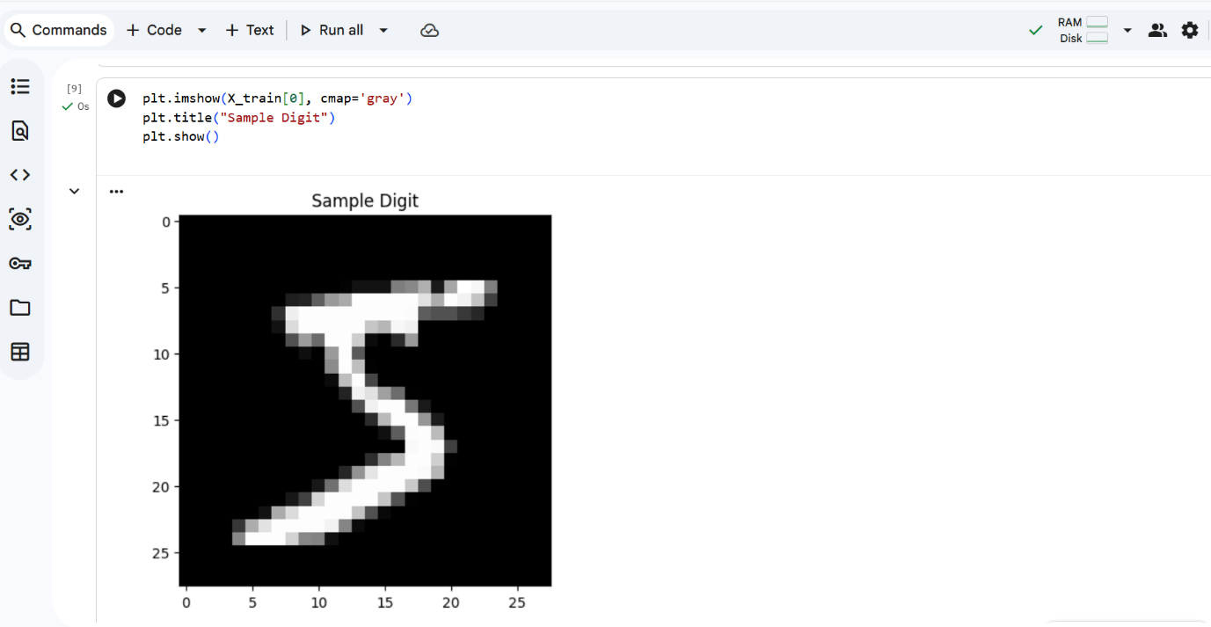
Dataset Preview.
4. Data Preprocessing
The following preprocessing steps were performed:
- Loaded dataset using Keras
- Normalized pixel values by dividing by 255
- Reshaped data for neural network input
- Verified dataset dimensions
Normalization helps the model train faster and improves performance.

5. Deep Learning Model Architecture
A Sequential Neural Network model was built with the following layers:
- Flatten layer (input layer)
- Dense layer with ReLU activation
- Output Dense layer with Softmax activation
The model was compiled using:
- Optimizer: Adam
- Loss function: Sparse Categorical Crossentropy
- Metric: Accuracy
6. Model Training
- The model was trained on the training dataset for 5 epochs. During training, the model learned patterns from handwritten digit images.
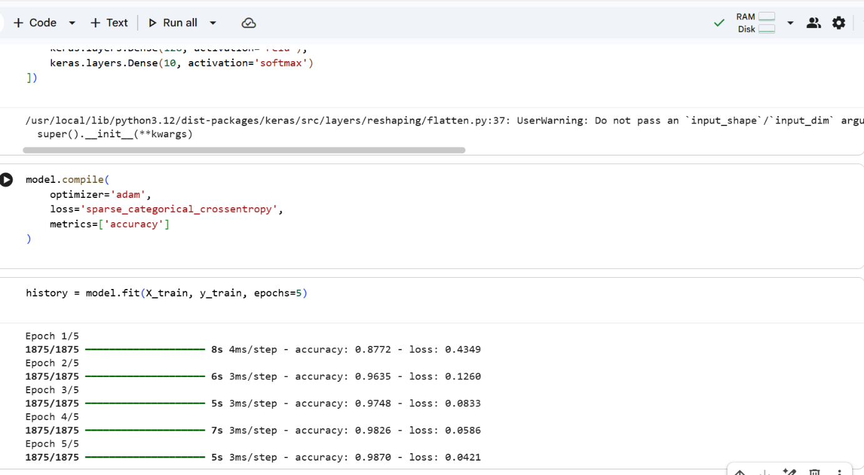
Model Training Output.
7. Model Evaluation
After training, the model was evaluated on the test dataset to measure its performance.
Result:
- Test Accuracy: (0.975499)
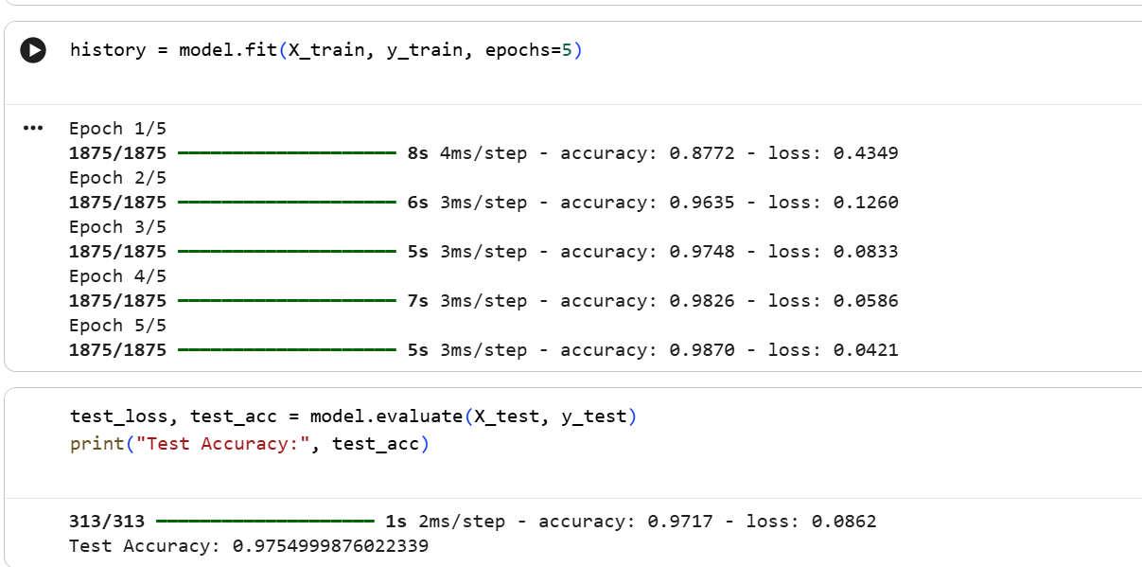 Model Accuracy Output.
The obtained accuracy shows that the deep learning model performs well on handwritten digit classification.
8. Conclusion
In this project, a deep learning model was successfully developed for handwritten digit classification using the MNIST dataset. The model achieved good accuracy and demonstrated the effectiveness of neural networks in image classification tasks. This project provided hands-on experience in deep learning model building, training, and evaluation.

